ATD Competencies Self-Assessment
Joanne Deitsch
UMUC

Author Note
Correspondence concerning this paper should be addressed to Joanne Deitsch, 20 Vine Street, #1543, Lansdale, PA 19446. E-mail: joanne@joannedeitsch.com

Association for Talent Development (ATD) Competencies Self-Assessment

Introduction
This paper assesses the student author’s competencies as measured against the Association for Talent Development’s (ATD) competency model (ATD, 2018). Foundational competencies, areas of expertise, and plans for closing skills gaps are discussed. A completed action planning for individuals’ job aid forms part of this discussion (ATD, 2014).
Foundational Competencies
The areas that are most important the student author’s current position are business skills and personal skills followed by interpersonal skills and technology literacy. Table 1 at the end of this section provides a completed ATD Foundational Assessment for the student author. The student author has succesfully completed of dozens of learning projects from the initial analysis through implementation and evaluation in a professional capacity at four different organizations over a ten year period. A current project requires the student author to develop a strategy around implenting virtual learning. The studen author actively participates in industry events sponsored by eLearning Guild (http://elearningguild.com), the Pennsylvania/Delaware/New Jersey Distance Education Association (http://padla.org), and the Greater Philadelphia Chapter of the Association for Talent Development (http://tdphl.org).
The next two areas of importance are interpersonal skills and technology literacy. The student author has learned how to build relationships with peers and subject matter experts to successfully complete learning projects. The student author must constantly update technical skills as the training solutions developed involve software application training. The student author also demonstrates competency with virtual learning platforms including Adobe Connect, LogMeIn GoToTraining, and WebEx Training Center as well as on-demand eLearning development tools including Articulate Storyline and Adobe Captivate.
The remaining competenices are of lower importance to the student author’s current job. The only learning audience in the student author’s current postion are North Americans. As a result, a global mindset does not apply for this assessment. The student author’s current organization does not require up to date knowledge of the industry. As discussed earlier, the student author does keep abreast of current industry trends through participation in learning industry associations.
Table 1
Foundational Assessment for Joanne Deitsch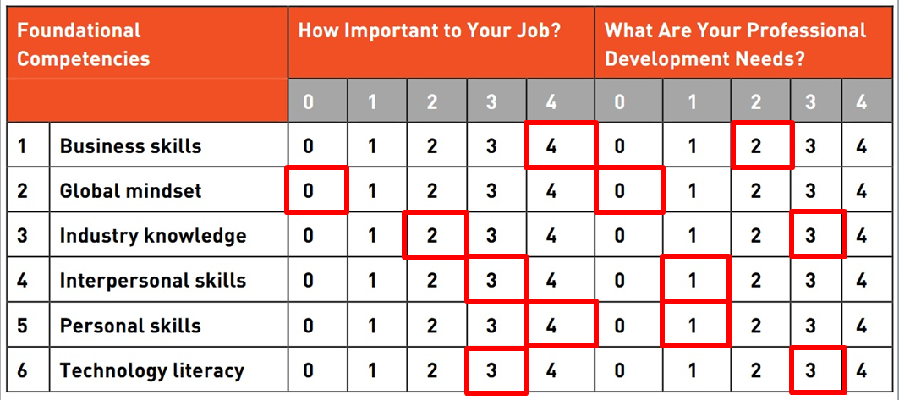

Training and Development Areas of Expertise
Virtual school classification can extend to student populations. Virtual schools provide an option for students wishing to accelerate academic progress (Watson, Gemin, Vashaw, & Pape,
Plan for Closing Skills Gap
The student author favors the classification system that Matthew Wicks and Associates (2010) described. The Clark and Watson classification systems require a prior understanding of the author’s definitions (Barbour, et al., 2009). Both systems only provide a handful of terms to describe virtual schools (Barbour, et al., 2009). The categorization that Matthew Wicks and

Areas of Training and Development Expertise
The student author holds instructional design as the most important area of expertise for current and future positions. As with most professional fields, the area of instructional design continually grows and changes requiring learning professionals to adapt and incorporate new ideas into practice (Van Dam, 2012). Table 2 at the end of this section provides a completed Areas of Expertise Assessment for the student author.
Learning technologies comprise the second area of expertise that requires improvement for the student author. “L&D [Learning and Development] functions need to design learning platforms that provide a personalized view on learning and are supported by social media features (for example, rated, recommended content) and up-to-date and relevant learning content” (Van Dam, 2012, p. 51). The concept of learning professionals learning all they need for career success in school no longer applies.
The third area of expertise for the student author’s current and future positions are training delivery. The student author has delivered dozens of live and virtual sessions in a professional setting. However, this area of expertise requires practice to keep skills sharp.
The last area of expertise for the student author’s current and future positions are evaluating learning impact. The student author has minimal experience with creating and analyzing metrics for the impact of learning solutions. Evaluations involving the use of net promoter scores (https://en.wikipedia.org/wiki/Net_Promoter) as well as with level 1 and 2 Kirkpatrick evaluations (https://www.kirkpatrickpartners.com/Our-Philosophy/The-Kirkpatrick-Model) are the limit of the student author’s expereince with evaluation methodologies.
The areas of change management, coaching, integrated talent management, knowledge management, managing learning programs, and performance improvement do not apply for futher analysis. These area of expertise either do not apply or are more slated for manageral roles that the student author has no aspirations to pursue.
Table 2
Areas of Expertise Assessment for Joanne Deitsch
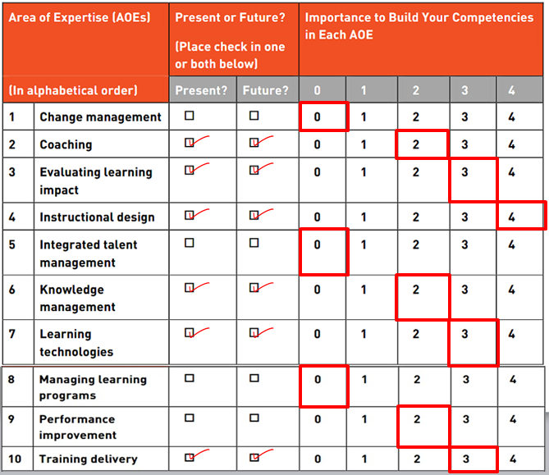

Plan for Closing Skill Gaps
Table 3 below provides a completed Action Plan for the student author’s skill gaps. The timeframe to complete all activities are March, 2019.
Table 3
Action Planning for Joanne Deitsch
Area of Expertise | Actions Steps | Resources
Instructional Design | Continue to design learning solutions | 1) On-the-job activities  2) Industry association involvement
Learning Technologies | Improve skills with Articulate Storyline | 1) Articulate Storyline Community of Practice  2) Training courses
Training Delivery | Continue to deliver training | On-the-job activities
Evaluating Learning Impact | Improve skills with evaluation methodologies | 1) Online research on Kirkpatrick Levels 3-4  2) Online research on other evaluation methodologies

Conclusion
While the student author has solid foundational skills as a learning professional, there are still are areas of expertise that require further development. In the coming year, the student author will continue to develop skills in the areas of instructional design, learning technologies, training delivery, and evaluating learning impact. This development will involve a mixture of on-the-job activities, industry association involvement, research, and course completion.

References
Association for Talent Development (ATD). (2018). ATD competency model [Web Page]. Retrieved from https://www.td.org/Certification/Competency-Model
Association for Talent Development (ATD). (2014). Using the ATD competency model action planning for individuals [Web Page]. Retrieved from http://files.astd.org.s3.amazonaws.com/Bookshelves/Job%20Aids/Compentency%20Model/Action%20Planning%20for%20Individuals.pdf?_ga=2.44576868.1112127462.1518928987-1304674894.1515462007
Van Dam, N. (2012, April). Designing learning for a 21st century workforce. T+D, 66(4), 49-53. Retrieved from https://www.td.org/td-magazine

