1. Classify the different cost items as either fixed or variable costs (matching row number to Fixed or Variable as appropriate) AND as capital or recurrent costs.
Fixed Costs: Items in Column B, rows 1 – 28 (with the exception of header rows)
Variable Costs: Items in Column B, rows 29 – 38 (with the exception of header rows)
Capital Costs: Items in Column B, rows 4 – 34 (with the exception of header rows)
Recurrent Costs: Item in Column B, Rows 2 – 3
2. Calculate the Recurrent Fixed Costs of course overheads (management and secretarial support).
Recurrent Fixed Costs = Management (ongoing) @25% of per annum salary + Secretarial Support (ongoing) 100% of per annum salary = 15,500+25,600 = 41,100
3. Calculate the aggregate Fixed Costs of Development (FD) and the aggregate Fixed Costs of Maintenance (FM).
Aggregate Recurrent Fixed Costs of Development = Total Fixed Costs of Development * 8 = 133,350 * 8 = 1,066,800
Aggregate Fixed Costs of Maintenance = 41,100 from step 2 * 8 = 328,800

4. Calculate the variable cost per student (V)
Summation of all student support costs + Summation of all replication and duplication costs = 399.20/student – from rows 27 through 34 in the spreadsheet
5. Calculate the depreciation rate on a basis of the lifetime of the presentation of the project (compare Rumble Table 6.1) and charge it to each year of presentation. (You may use the format of the attached spreadsheet.)
6. Following the template of Rumble Table 6.4, annualize the Fixed Costs of Development (FD) over the six years of presentation at 7.5% interest and the Fixed Costs of Maintenance (FM) over four years at the same rate.
Annualize FD over 8 years @ 7.5% = FD Cost * Annualization rate = 133,350 * 0.171 = 22,802.85
Annualize FD over 6 years @ 7.5% = FD Cost * Annualization rate = 133,350 * 0.213 = 28,403.55
Annualize FM over 4 years @ 7.5% = FD Cost * Annualization rate = 11,250 * 0.299 = 3363.75
7. Summarize in a short paragraph the reasons for and against annualization.
In Chapter 6, Rumble (1997) discusses how annualization can be used to capture the foregone interest that is lost due to the investment that is made by the organization. This could be seen as the true depreciation cost as it not only accounts for the depreciation of the item but also captures the foregone interest (Rumble, 1997). Rumble (1997) cites Eicher who believes that annualization is not realistic as public bodies funding educational projects do not have the ability to find alternative uses for the money – they must use the money for the project.
8. Calculate the equation of total costs (TC=F+VxN) using the annualized figure of fixed costs and N=900
Total Cost = Annualized Fixed Costs + Variable Costs * Number of Students = 53,837 + 399.20 * 900 = 53,837 + 359,280 = 413,117
9. Draw the graph of the total cost function using, as above, the annualized figure of fixed costs while N varies over the accumulated number of students (i.e. N= 150, 300, 450 etc.)
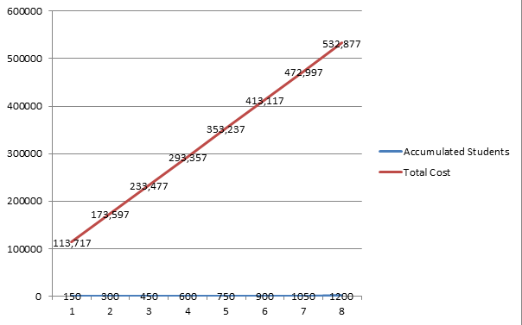

10. Calculate the equation of average costs (AC=F/N+V) using the annualized figure for fixed costs and N=900
Average Costs = Annualized Fixed Costs / Number of Students + Variable Costs = 53,837 / 900 + 399.20 = 53,837 / 1299.2 = 41.44
11. Draw the graph of the average cost function, using, as above, the annualized figure of fixed costs while N varies over the accumulated number of students (i.e. N= 150, 300, 450 etc.)
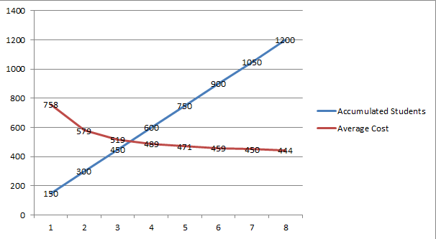
12. If the student is charged the per student fee specified calculate the break-even point. (Use the equation TC=F+VxN and the income equation: I=SFxN (Income =Student Fee x No of students). The break-even point is N=F/(SF-V)
N = Fixed Costs / (Student Fee – Variable Costs) = 185,700 / (1,140 – 399.20) = 185,700 / 740.8 = 250.67
Since you can’t have a factional student round up – N = 251
13. Represent the break-even point graphically (overlaying the graphs of TC and I).
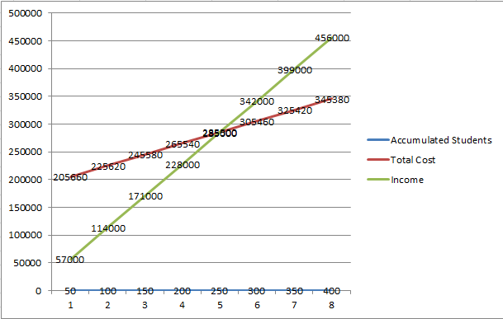

14. Summarize in a short paragraph why it is believed that the TC and AC equations and the specific cost structure of DE suggests that DE may be more cost-efficient than conventional modes of educational provision.

Total Cost and Average Costs suggest that DE may be more cost efficient as shown in the graphics above. More students can be accommodated by DE as the content development portion of teaching is separated from student support (Rumble, 1997). The average cost per student decreases as student enrollments rise unhindered by the physical constraints of conventional education.

REFERENCES
Rumble, G. (1997). The costs and economics of open and distance learning [Adobe Digital Editions Version]. Retrieved from Amazon.com

